2023-2024 Calendar
Sacrament and Related Meeting Dates

CANDLE SERVICE (First Communion Prep Class)
- Monday, November 6th at 7pm in Church

FIRST RECONCILIATION
Parent Meeting(s) in UGC Multi-Purpose Room
- Sunday, December 10th at 1:15pm OR Monday, December 11th at 7pm
Retreat(s) in UGC Multi-Purpose Room
- Sunday, January 21st at 1:15pm OR Monday, January 22nd at 6:30pm
*First Reconciliation Prayer Service(s) in Church
- Saturday, February 24th
      - 11am Last Names TBA
      - 1pm Last Names TBA

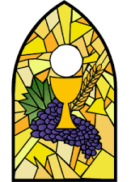
FIRST COMMUNION
Parent Meeting(s) in UGC Multi-Purpose Room
- Sunday, March 3rd at 1:15pm OR Monday, March 4th at 7pm
Retreat(s) Saturday, March 16th in the UGC Cafeteria and Church
      - 9am-11:30am. Last Names TBA
      - or 1-3:30pm Last Names TBA
First Communion Rehearsals
- Wednesday, May 1st at 4:30pm Last Names TBA
- Thursday, May 2nd at 4:30pm Last Names TBA
*First Communion Mass(es)
- Saturday, May 4th
      - 10:30am Last Names TBA
      - 1pm Last Names TBA

CONFIRMATION (8th Grade)
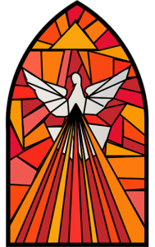
Confirmandi, Parent, & Sponsor Meeting
- Sunday, October 15th at 1:15pm in the UGC Gym [Following the 12pm Mass]
Retreat at the UGC & Church
- Saturday, February 10th at 12:30pm-6:00pm (ending with 5pm Mass)
Confirmation Rehearsal
  - Wednesday, April 10th at 7pm Last Names TBA
  - Thursday, April 11th at 7pm Last Names TBA
*Confirmation Mass(es)
  - Saturday, April 13th
    - 10am Last Names TBA
    - 1:30pm Last Names TBA

